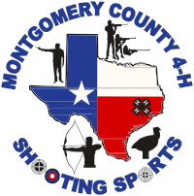
2022 Gulf Coast BB Gun, Air Rifle & Archery Match
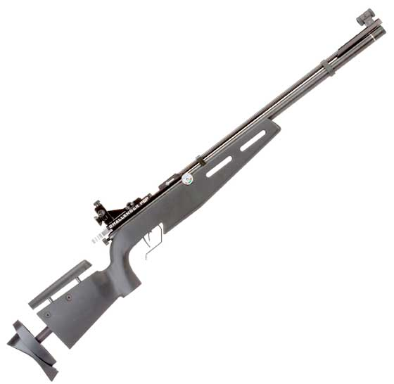
When: Sunday, February 6, 2022
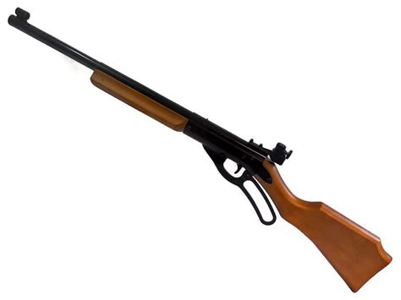
Time: 8:00 A.M. – 5:00 P.M.
Where: Montgomery County Fairgrounds Conroe, TX
Hosted by: Montgomery 4-H Shooting Sports
Events:
- NRA Approved 5 meter BB gun (4 x 10 with written test)
- 10 meter sporter air rifle (3 x 20) PSK
- Archery: Bow Classes - Compound/NASP/Barebow/Recurve (40 cm target face)
  - Junior distance will be 9 meters. Intermediate/Senior distance will be 18 meters
Competition Open To:
- BB Gun: Youth 8 years old (and in 3rd grade) to 15 years old (15 y.o.s may compete if their 16th birthday occurs after 1st day of 2022 Daisy Nationals). Limit: 60 competitors
- Air rifle: Youth 8 years old (and in 3rd grade) through 12th grade. Limit: 20 competitors
- Archery: Youth 8 years old (and in 3rd grade) through 12th grade. Limit: 40 competitors
Entry fees:
- $20 per individual per event
- $10 per team per event (BB gun or air rifle)
Entry Deadline: Regular entries accepted November 15, 2021 through January 1, 2022. Late entries accepted through January 15, 2022, as space allows.
Awards:
- BB Gun:
  - Individual Medals: Overall (Aggregate) 1st- 3rd by age group; Top Shot 1st -3rd; New Competitor Class 1st – 3rd Overall (Aggregate)
  - Team Medals: 1st – 3rd Place Teams
  - Individual Ribbons: 1st-3rd place in each position by age group
- Air Rifle:
  - Medals for Individual Overall 1st – 3rd
  - Medals for 1st – 3rd Place Teams
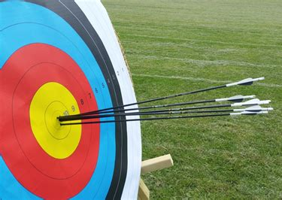
- Archery:
  - Individual Medals 1st-3rd per Division and Class
Contact: Laura Haines at laurahaines44@gmail.com for match bulletin and registration forms.

