Requesting an Absentee Ballot Online
- Go to myvote.wi.gov and click the gray “Vote Absentee” tile.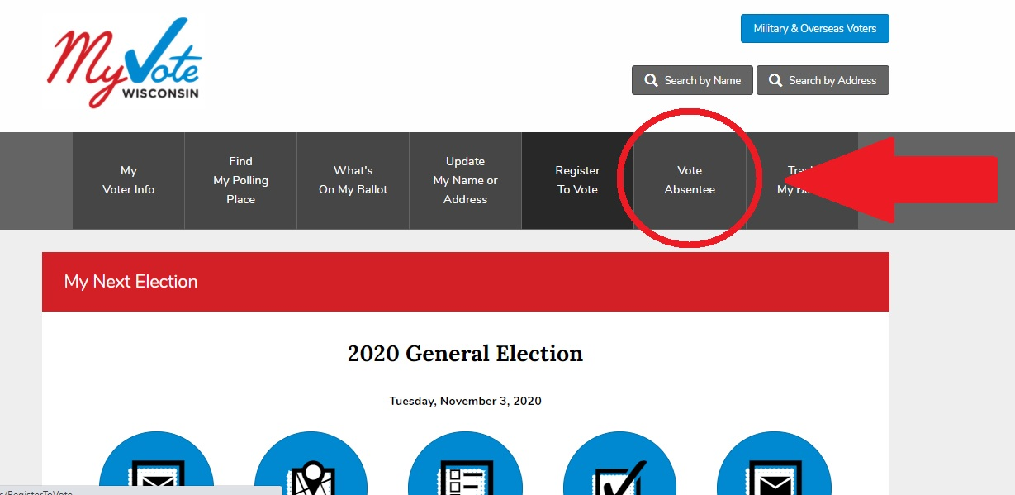

- Enter your first name, last name and date of birth (all three fields must be filled out) to search for your voter record.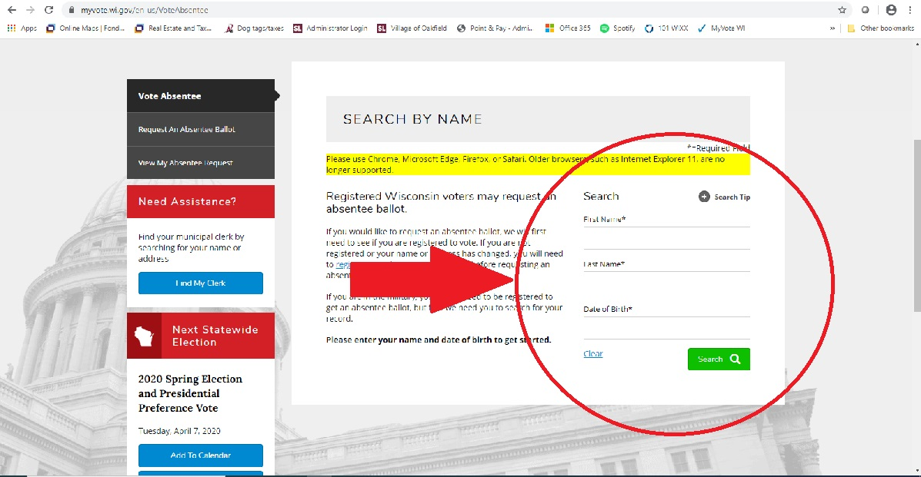

- If you are a registered voter it will display so on the screen. Review your record to ensure accuracy. If all the information is correct select the blue “Request Absentee Ballot” button. 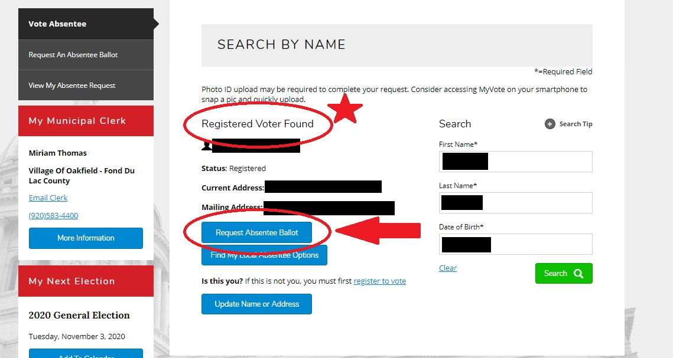

- On the next screen you MUST check the box verifying your name and address are correct to move on (see picture below). 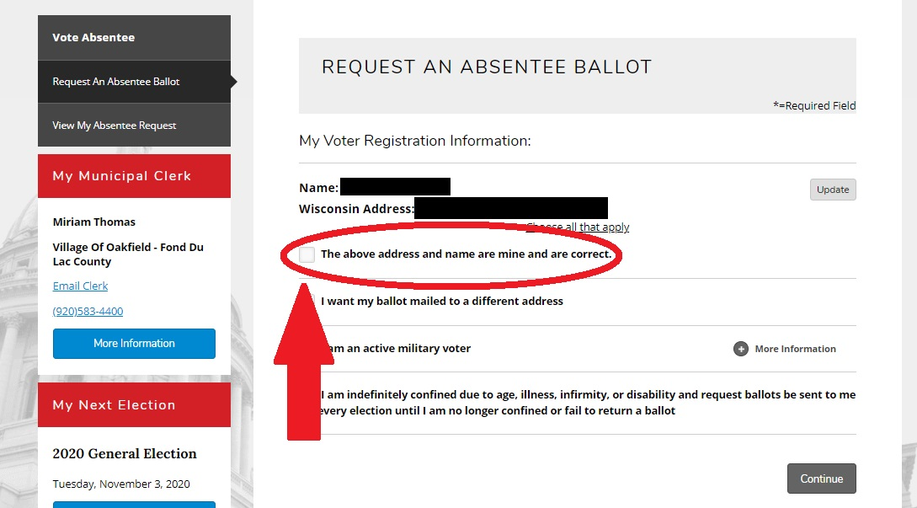
- If you would like your ballot mailed to a different address (or PO Box) than the one shown you can select that option on the same screen. See below. 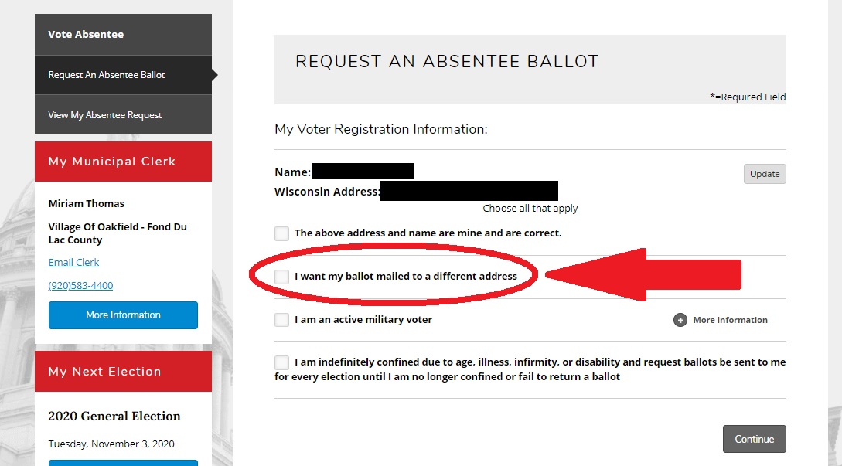

- If the name and/or Wisconsin Address shown are incorrect you again have the option to update the information on this screen. 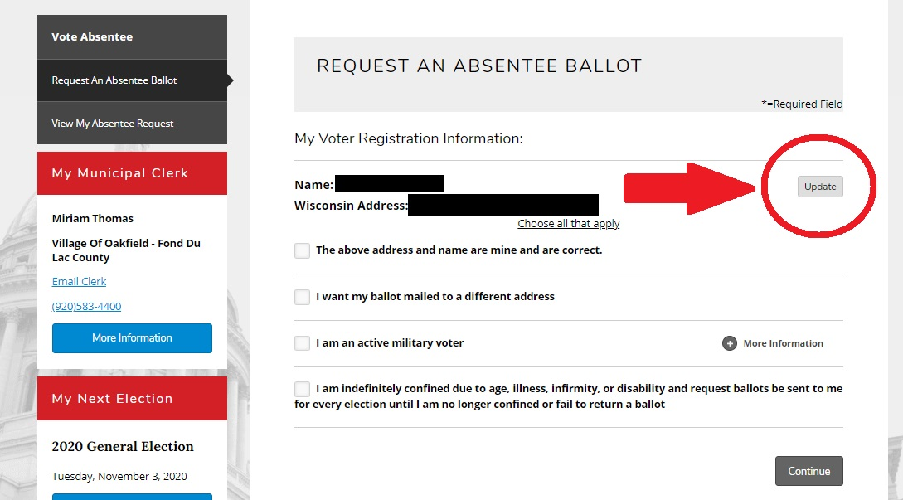

- The next screen will require submitting a valid form of photo ID. Click on the green button (shown below) to attach a photo or document to satisfy this requirement. If you are requesting your ballot from a smart phone you will have the option to take a photo using your device and attach it to your request. 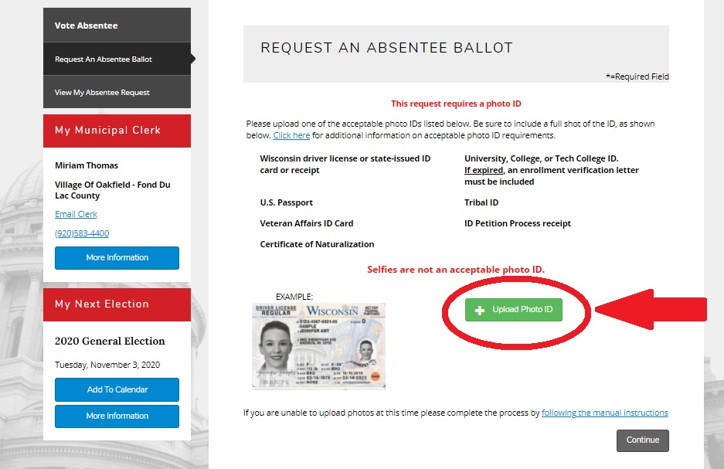
- Now you will select the election(s) for which you are requesting a ballot. Select your desired choice. 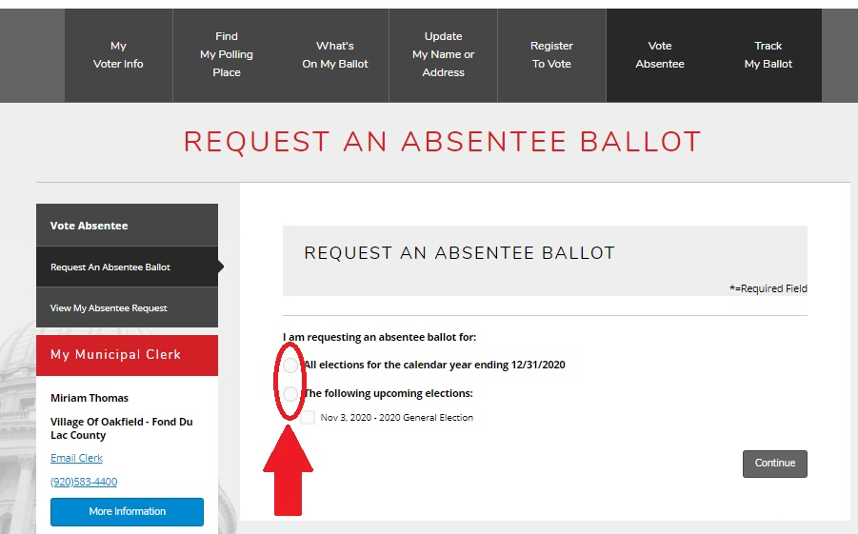

- Review your information carefully on the final page and check the box to indicate everything is correct. Also please consider entering your e-mail and/or phone number; this helps greatly and is a much quicker method if we need to contact you regarding your request.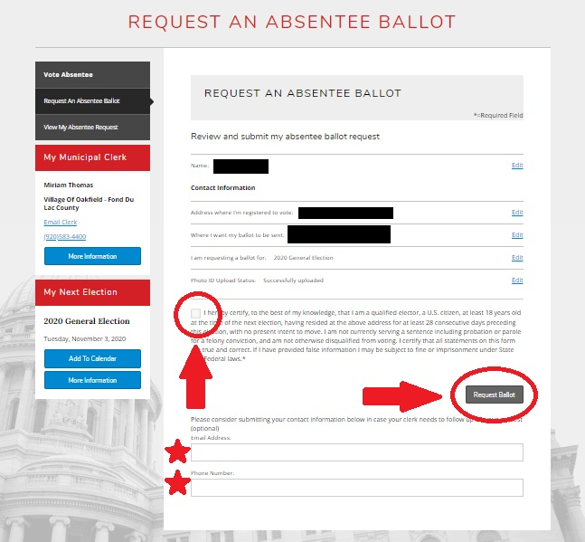

- Click the “Request Ballot” button; you’re all done! You ballot will be on the way to you within one business day!

