Subscribing to Text/Email Tax Notifications

- Go to https://landinfo.fdlco.wi.gov/Ascent/PropertyListing/RealEstateTaxParcel#/Search and click on the link to subscribe.
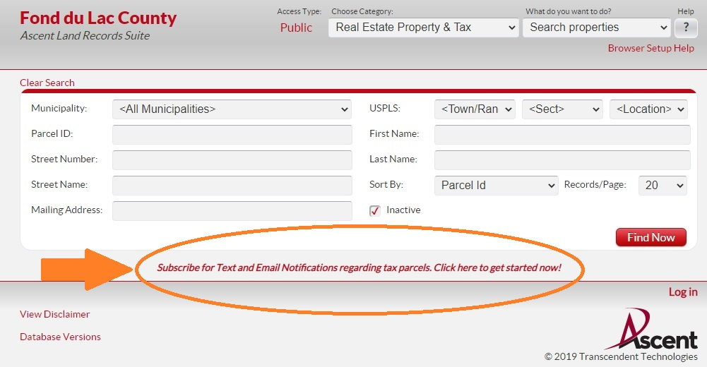
- Enter your name, phone number where you would like to receive notifications and e-mail address.
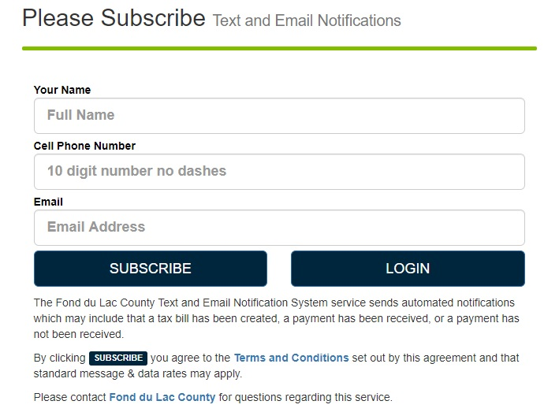

- Find the property(ies) for which you would like payment notifications. Include directional (north, south, east, west) in your search. If you need help finding your property, call the office. Sometimes finding a parcel can be difficult due to the way land information has it recorded.
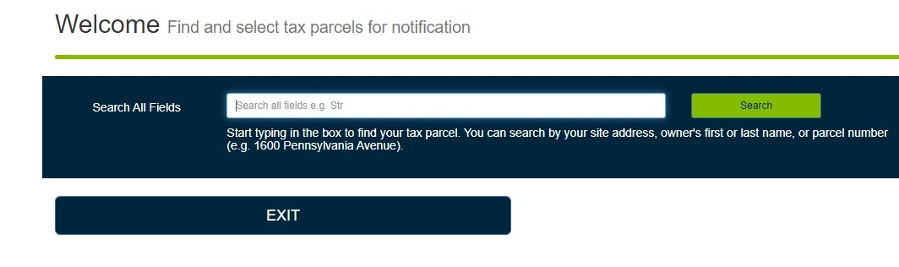

- Any records your search returns will show up in a list. Select each parcel for which you would like to be notified.
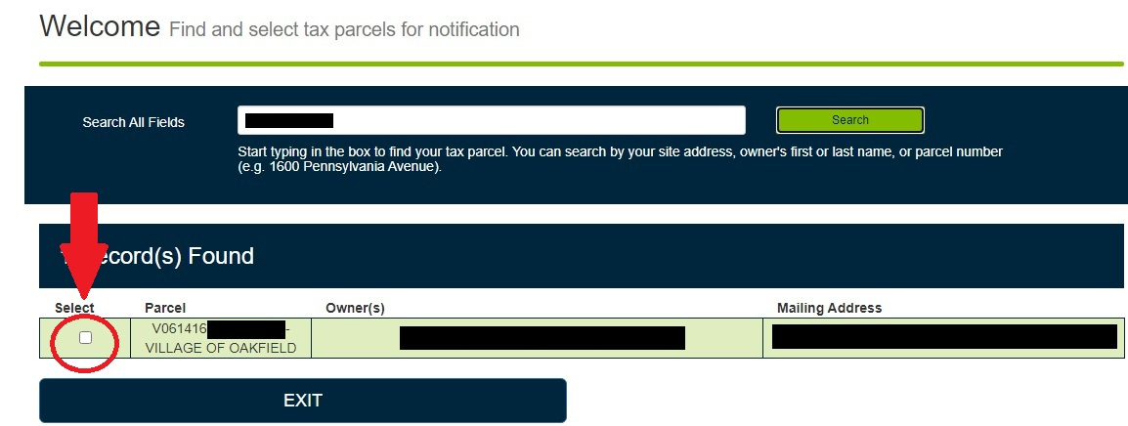

- Select how you would like to be notified, either by text or email. Click on either icon (or none) for each of the four options. If you select an option the green icon will change to navy blue.
- 